**Homework Lecture 3**

1)On which network is this transaction? 0xb97e091e42252571072ae9c605bda16c8f2568cb6a4ff8fd717d384123074b55

***Conflux Network***

**2)Find a block with 20 or more transactions and send us the block hash.**

3)Try to find a failed transaction. Did the sender retry?

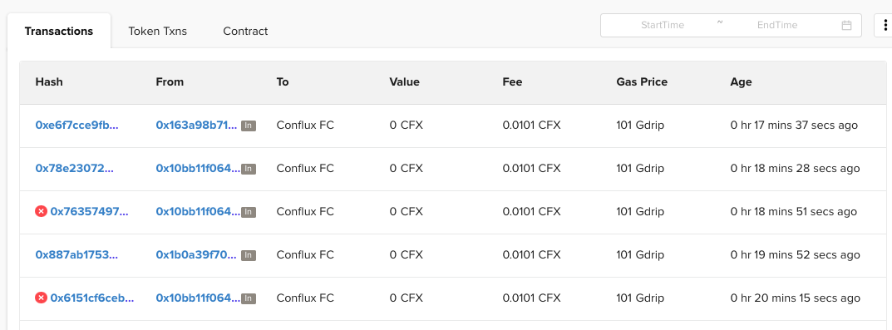

*Failed First try:***0x6151cf6ceb0d2156e6f35c258d94e27ebc299d149ee664544db343c8e5d29520**

*Failed Second try:* **0x7635749799dafce791bb952d7a83859c1c4faca8f6cb3d2652fabb073a992241**

*Successful Third try:*

**0x6151cf6ceb0d2156e6f35c258d94e27ebc299d149ee664544db343c8e5d29520**

4)Create a wallet, get some CFX through the faucet and send us the corresponding transactions hash.

**0xbb14c0d4bb46a5198f7de3f516b32228be737e1c818e20ad5fa2f91ff01ea94f**

5)Buy a ticket on 167.172.160.61 and send us the corresponding transaction hash.

**0x331d3f6456a462ef4cb1071ba0c42e0b2a57e37c727bde4f172d2e9502d988f2**

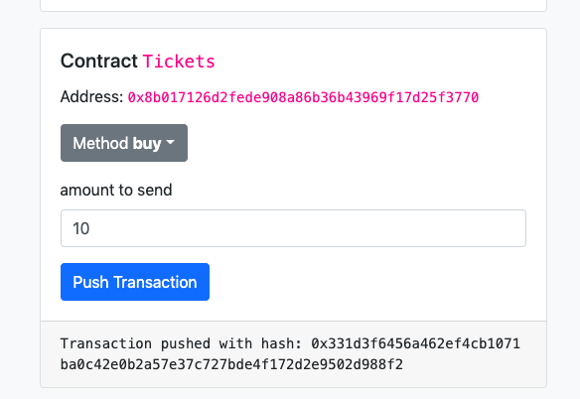

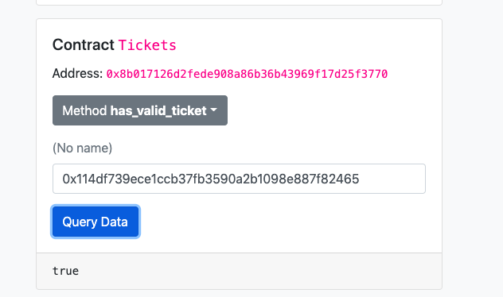

5.1)What happens if you lower the gas limit before sending the transaction?

**It will recalculate the total amount paid, but the lowest limit is 21000.**

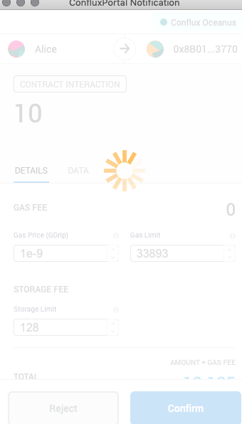

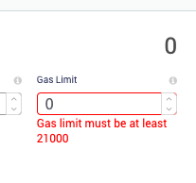

 5.2)What happens if you try to buy a second ticket for the same address?

**Error message shows up**

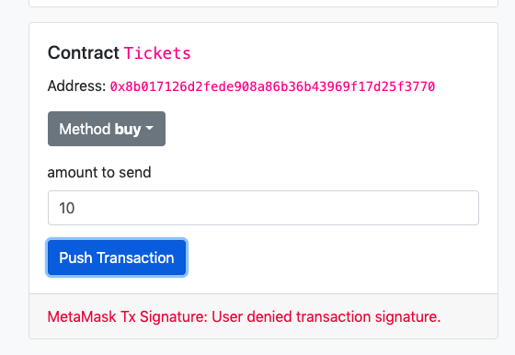

6)Try querying recent ticket purchases. Has there been any?

**Yes by me**

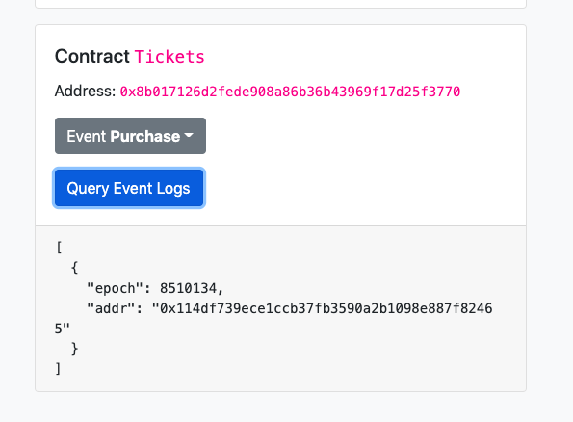

7)Who is the creator of the Tickets contract?

**0x1dbda5dd2e952914bc74a802510d0fa59f9d7636**

**8)What is the balance of this account? How do you think this account acquired these tokens?**

It has zero tokens?

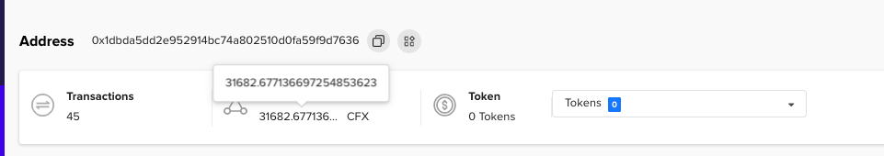

**9)Which address holds the most FC tokens?**